**Get Data**

1. U10, V10, SLP in single levels

import cdsapi

dataset = "reanalysis-era5-single-levels"

request = {

"product_type": ["reanalysis"],

"variable": [

"10m_u_component_of_wind",

"10m_v_component_of_wind",

"mean_sea_level_pressure"

],

"year": ["2022"],

"month": ["03"],

"day": [

"01", "02", "03",

"04", "05", "06",

"07", "08", "09",

"10", "11", "12",

"13", "14", "15",

"16", "17", "18",

"19", "20", "21",

"22", "23", "24",

"25", "26", "27",

"28", "29", "30",

"31"

],

"time": [

"00:00", "06:00", "12:00",

"18:00"

],

"data_format": "netcdf",

"download_format": "unarchived"

}

client = cdsapi.Client()

client.retrieve(dataset, request).download()

1. T, H in pressure levels

import cdsapi

dataset = "reanalysis-era5-pressure-levels"

request = {

"product_type": ["reanalysis"],

"variable": [

"geopotential",

"temperature"

],

"year": ["2022"],

"month": ["03"],

"day": [

"01", "02", "03",

"04", "05", "06",

"07", "08", "09",

"10", "11", "12",

"13", "14", "15",

"16", "17", "18",

"19", "20", "21",

"22", "23", "24",

"25", "26", "27",

"28", "29", "30",

"31"

],

"time": [

"00:00", "06:00", "12:00",

"18:00"

],

"pressure_level": ["300", "400", "500"],

"data_format": "netcdf",

"download_format": "unarchived"

}

client = cdsapi.Client()

client.retrieve(dataset, request).download()

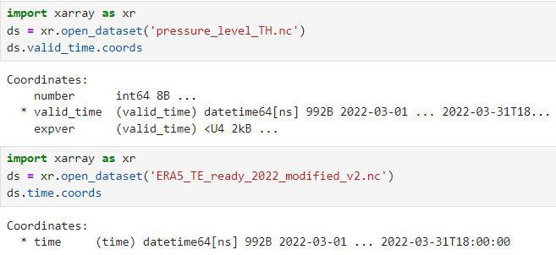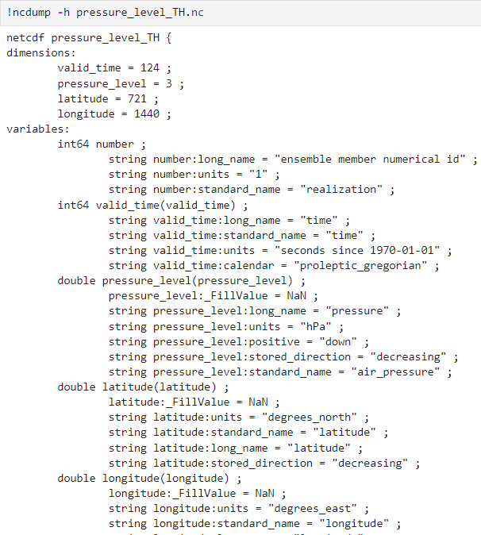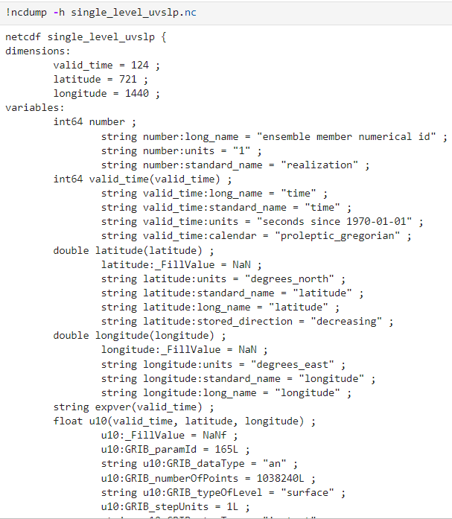

**Merge Data**

We try to adjust the attributes of the obtained data to match the attributes of TE_ready_198001.nc.

We started by adjusting each variable of the data one by one.

Lat:

import xarray as xr

ds = xr.open_dataset('/data0/zy2608/ERA5_ready.nc')

ds = ds.rename({'latitude': 'lat'})

if 'standard_name' in ds['lat'].attrs:

del ds['lat'].attrs['standard_name']

if 'stored_direction' in ds['lat'].attrs:

del ds['lat'].attrs['stored_direction']

ds['lat'].attrs.update({

'long_name': 'latitude',

'units': 'degrees_north',

'vmax': 1.e+15,

'vmin': -1.e+15

})

ds.to_netcdf('/data0/zy2608/ERA5_lat_ready_updated.nc')

SLP:

import xarray as xr

ds = xr.open_dataset('/data0/zy2608/ERA5_lat_ready_updated.nc', mode='r+', engine='netcdf4')

ds = ds.rename({'slp': 'SLP'})

attrs_to_remove = [

'GRIB_paramId', 'GRIB_dataType', 'GRIB_numberOfPoints', 'GRIB_typeOfLevel',

'GRIB_stepUnits', 'GRIB_stepType', 'GRIB_gridType', 'GRIB_uvRelativeToGrid',

'GRIB_NV', 'GRIB_Nx', 'GRIB_Ny', 'GRIB_cfName', 'GRIB_cfVarName',

'GRIB_gridDefinitionDescription', 'GRIB_iDirectionIncrementInDegrees',

'GRIB_iScansNegatively', 'GRIB_jDirectionIncrementInDegrees',

'GRIB_jPointsAreConsecutive', 'GRIB_jScansPositively',

'GRIB_latitudeOfFirstGridPointInDegrees', 'GRIB_latitudeOfLastGridPointInDegrees',

'GRIB_longitudeOfFirstGridPointInDegrees', 'GRIB_longitudeOfLastGridPointInDegrees',

'GRIB_missingValue', 'GRIB_name', 'GRIB_shortName', 'GRIB_totalNumber', 'GRIB_units',

'GRIB_surface', 'coordinates'

]

for attr in attrs_to_remove:

if attr in ds['SLP'].attrs:

del ds['SLP'].attrs[attr]

ds['SLP'].attrs.update({

'long_name': 'sea_level_pressure',

'units': 'Pa',

'fmissing_value': '1.e+15f',

'standard_name': 'sea_level_pressure',

'vmax': '1.e+15f',

'vmin': '-1.e+15f',

'valid_range': ['-1.e+15f', '1.e+15f'],

'add_offset': '0.f',

'scale_factor': '1.f',

'missing_value': '1.e+15f'

})

encoding = {

'SLP': {

'_FillValue': 1.e+15,

}

}

ds.to_netcdf('/data0/zy2608/ERA5_ready_slp_modified.nc', mode='w', engine='netcdf4', encoding=encoding)

Then we use ERA5_ready_slp_modified.nc updated data to reduce and set attributes in slp:

import xarray as xr

ds = xr.open_dataset('/data0/zy2608/ERA5_ready_slp_modified.nc', mode='r+', engine='netcdf4')

ds = ds.rename({'U10': 'U10M'})

attrs_to_remove = [

'GRIB_paramId', 'GRIB_dataType', 'GRIB_numberOfPoints', 'GRIB_typeOfLevel',

'GRIB_stepUnits', 'GRIB_stepType', 'GRIB_gridType', 'GRIB_uvRelativeToGrid',

'GRIB_NV', 'GRIB_Nx', 'GRIB_Ny', 'GRIB_cfName', 'GRIB_cfVarName',

'GRIB_gridDefinitionDescription', 'GRIB_iDirectionIncrementInDegrees',

'GRIB_iScansNegatively', 'GRIB_jDirectionIncrementInDegrees',

'GRIB_jPointsAreConsecutive', 'GRIB_jScansPositively',

'GRIB_latitudeOfFirstGridPointInDegrees', 'GRIB_latitudeOfLastGridPointInDegrees',

'GRIB_longitudeOfFirstGridPointInDegrees', 'GRIB_longitudeOfLastGridPointInDegrees',

'GRIB_missingValue', 'GRIB_name', 'GRIB_shortName', 'GRIB_totalNumber', 'GRIB_units',

'GRIB_surface', 'coordinates'

]

for attr in attrs_to_remove:

if attr in ds['U10M'].attrs:

del ds['U10M'].attrs[attr]

if '_FillValue' in ds['U10M'].attrs:

del ds['U10M'].attrs['_FillValue']

ds['U10M'].attrs.update({

'long_name': '10-meter_eastward_wind',

'units': 'm s-1',

'fmissing_value': float(1.e+15),

'standard_name': '10-meter_eastward_wind',

'vmax': float(1.e+15),

'vmin': float(-1.e+15),

'valid_range': [float(-1.e+15), float(1.e+15)],

'add_offset': float(0.0),

'scale_factor': float(1.0),

'missing_value': float(1.e+15)

})

ds.to_netcdf('/data0/zy2608/ERA5_ready_U10M_modified.nc', mode='w', engine='netcdf4')

However, there is something wrong with the code:

We don’t know how to solve it.

Therefore, we change another method to update attributes of the data:

import xarray as xr

ds_surface = xr.open_dataset('single_level_uvslp.nc')

ds_surface = ds_surface.rename({

'latitude': 'lat',

'longitude': 'lon',

'valid_time': 'time',

'msl': 'SLP',

'u10': 'U10M',

'v10': 'V10M'

})

ds_pl = xr.open_dataset('pressure_level_TH.nc')

ds_pl = ds_pl.rename({

'latitude': 'lat',

'longitude': 'lon',

'valid_time': 'time',

'pressure_level': 'lev',

't': 'T',

'z': 'H',

})

# Convert geopotential to geopotential height (H) in meters

ds_pl['H'] = ds_pl['H'] / 9.80665

ds_pl['H'].attrs['units'] = 'm'

ds_pl['H'].attrs['long_name'] = 'geopotential_height'

ds_pl['H'].attrs['standard_name'] = 'geopotential_height'

# Select variables to merge

ds_surface_vars = ds_surface[['SLP', 'U10M', 'V10M']]

ds_pl_vars = ds_pl[['T', 'H']]

# Merge datasets

ds_combined = xr.merge([ds_surface_vars, ds_pl_vars])

# Ensure time coordinates are consistent

ds_combined['time'] = ds_surface['time']

# Save to NetCDF

ds_combined.to_netcdf('ERA5_TE_ready_2022.nc')

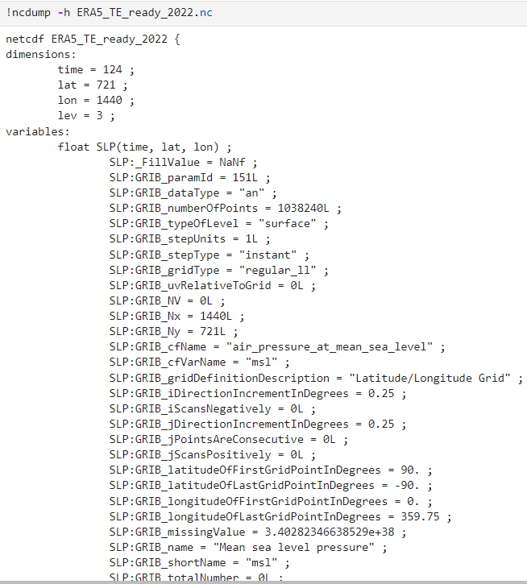

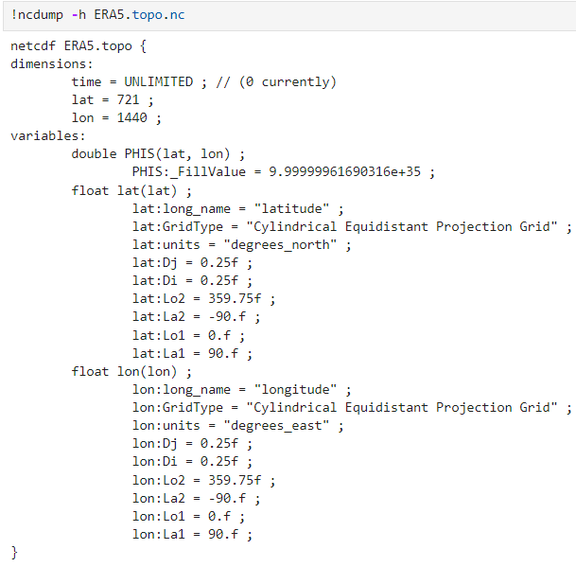

**Unity of attributes and variables**

Please see the codes in Github

